Time Series Analysis

Week 6 Material | 21 August 2017 | Due: 28 August 2017

Contents

Introduction 2

Plotting Time Series Data 2

Additive and Multiplicative Models 3

Additive Model 3

Multiplicative Model 3

Parts of time series 4

Deterministic 4

Stochastic 4

Functions in Time Series Analysis 5

General Parameters 5

Mean and Variance function 5

Covariance 5

Auto-covariance function (AC**V**F) 5

Autocorrelation function (ACF) 6

Purely random Process (White noise) 7

Simulating in R 7

Examples 7

Random Walk Process 8

Mean Value 10

Variance 10

Autocovariance 10

Autocorrelation 10

Drift 10

Simulating in R 10

Moving Average Process 11

Variance of $Zt$ 11

Autocovariance 11

Autocorrelation 11

Example Problem from Lecture Notes 12

Solving the Mean value function 12

Solving the Mean Value function in R 12

Stationary Time Series 13

Example 14

Appendix 15

Plot of Various Time Series Functions 15

Comparison of White Noise and Random Walk Data 16

# Introduction

Classical Statistical methods require the following assumptions:

1. Observations are independent
2. Observations are from the same population (i.e. probability distribution)
3. If the Statistical Method is *parametric*:
   * The data follows a particular probability distribution (e.g. Normal or Chi)

Where observations are non-independent due to the fact that they were collected sequentially over time classical statistical methods may not be appropriate and Time Series Analysis comes into play.

Imagine, rolling a dice, if at 10am a dice was rolled and the result was a 6, the probability of rolling a 6 at 11 am would not be affected. However if at 10am the thermometer read 35 OC it would be quite unlikely for the thermometer to read 5 OC at 11am, due merely to the fact of the past observation. This is why Time Series Analysis is useful.

Where observations are non-independent due to the fact that they were collected in close proximity (space) techniques known as spatial statistics are used.

## Plotting Time Series Data

Time series data is an observation ( $y_{t})$ plotted against the date $(x)$, e.g.:

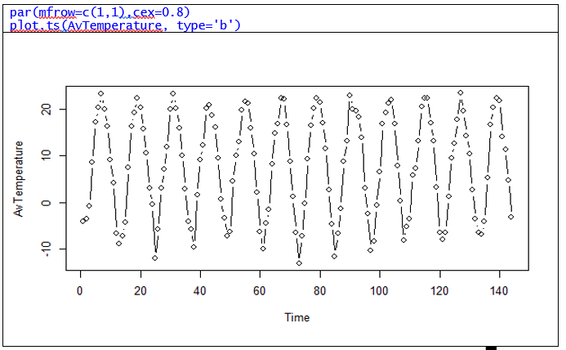

## Additive and Multiplicative Models

Time series can be broken up into four types of components:

* Trend (T)
* Cycle (C)
* Seasonal (S)
* Irregular (I)

These are best illustrated by way of a diagram:



It is assumed that these components interact in either an additive or multiplicative fashion

|  |  |
| --- | --- |
| Additive Model $$Y=T+C+S+Z$$ This is used where data is of similar magnitude (trend-free or over a short run) with constant absolute growth or decline | Multiplicative Model $$Y=T×C ×S×Z$$ This is used where data is of increasing or decreasing magnitude (long run or trended data) with constant percent growth or decline. |

The multiplicative model becomes additive as logarithms are taken (of non-negative data).

## Parts of time series

Time series have two major parts, a **deterministic** part and a **stochastic** part.

### Deterministic

The **deterministic** part may consist of various effects, such as,

* $T_{t}$ Long-term Trend-The general movement over all years;
* $C_{t}$ Cyclical effect – repetitive up and down movements about a trend that covers several years; Cyclical trends will go up and down randomly.
* $S_{t}$ Seasonal effect – repetitive cyclical pattern within a year (or a week or other smaller time period), Seasonal effects will have a constant pattern.

### Stochastic

The **stochastic** component is the random variation ${ Z}_{t}$.

* $Z_{t}$ Essentially this is just random error and fluctuation, irregular difficult to explain movement of data. (Also donated by $I_{t}$).

If data is *independent and identically distributed* (i.i.d.) then the additive time series model becomes a multiple linear regression (from wk. 5 material; how to use a multiple linear regression to model this is discussed in Wk. 7).

Generally the data is a sequence of successive dependent observations and special time series models are used (discussed in Wk. 8).

# Functions in Time Series Analysis

## General Parameters

### Mean and Variance function

The ***mean*** and ***variance*** function of a time series $\{Z_{t}\}$ is defined by:

|  |  |
| --- | --- |
| $$μ_{t}=E\left(Z_{t}\right)$$ | $$σ_{t}^{2}=var(Z_{t})$$ |

$E\left(X\right)$ refers to the expected value of random variable $x$, these are both functions of $t$.

### Covariance

In the previous notes Covariance was defined as:

$$Cov\left(X,Y\right)=\frac{1}{\left(n-1\right)}\sum_{i=1}^{n}{\left[\left(x_{i}-\overline{x}\right)\left(y_{i}-\overline{y}\right)\right]}$$

Covariance can also be defined more broadly as the expected product of their deviations from their individual expected values:[1]

The reference book provides:[2]

### Auto-covariance function (AC**V**F)

The ***auto covariance*** function of $Z_{t}$ is defined by:

$$γ_{t},_{ s}=Cov\left(Z_{t}, Z_{s}\right)$$

$$γ_{k}=Cov(Z_{t}, Z_{t-k})$$

This is a function of $t$ and $s$; $k=t-s$

### Autocorrelation function (ACF)

The autocorrelation is a measure of how a random variable (say $x$), varies over time relative to past observations (of say $x_{t-1}$). E.g. If the temperature was higher than average at 12 pm, we would expect the temperature to be above average at 1pm.

The ***autocorrelation function*** (ACF) is defined by:

$$ρ_{t,s}=Corr\left(Z_{t}, Z_{s}\right)=\frac{Cov\left(Z_{t}, Z_{s}\right)}{\sqrt{Var\left(Z_{t}\right)∙Var(Z_{s})}}$$

The lag-1 auto correlation for some time series is:

$$ρ_{1}=Corr\left(Z_{t},Z_{t-1}\right)=\frac{Cov\left(X_{t}, X_{t+1}\right)}{Var\left(X_{t}\right)}$$

The lag- $k$ auto correlation is defined:

$$ρ_{k}=\frac{Cov\left(X_{t}, X_{t-k}\right)}{\sqrt{Var\left(X_{t}\right)∙Var(X_{t-k})}}=\frac{γ_{1}}{y_{0}}=\frac{y_{1}}{σ_{X}^{2}}$$

Where:

$k=t-s$

* $γ_{1}$ denotes the lag-1 autocovariance,
* $γ_{0}$ is the lag-0 autocovariance and is equal to the variance.
* The lag-0 auto correlation is 1 (because obviously each value is correlated with itself).

$Cov\left(X,Y\right)=\frac{\sum_{i=1}^{n}{\left[(x_{i}-\overline{x})(y_{i}-\overline{y})\right]}}{(n-1)}$

## Purely random Process (White noise)

A white noise process has a mean value of zero and NO correlation between its values at different times, hence any random distribution (discrete or continuous) can be white noise (e.g. Normal, Uniform, Poisson, Binomial, Log-Normal, Chi, Gamma, Beta, Weibull, Exponential etc.).

So the definitions are:

Purely Random Process (AKA White Noise):

* Autocorrelation of 0 for all values
  + This is for all the data lag-1, lag-2, lag-3 …
* Auto covariance of 0
  + This is for all the data lag-1, lag-2, lag-3 …
* Constant Mean value (e.g. 0)

A white noise process may represent the error observed in a model, in this case the white noise process will have a mean value of 0.

Expressed more formally a white noise process is:

$$μ_{t}=E\left(x_{t}\right)=μ \\ σ_{t}^{2}=Var\left(X_{t}\right)=σ \\ γ_{t},_{ s}=Cov\left(X_{t}, X_{s}\right)=\left\{\begin{aligned}σ^{2}, t=s \\ 0, t≠s\end{aligned}\right. \\ γ_{t},_{ s}=Corr\left(X_{t}, X_{s}\right)=\left\{\begin{aligned}1, t=s \\ 0, t≠s\end{aligned}\right.$$

## Simulating in R

WN_1 <- arima.sim(model=list(order=c(0,0,0)), n=50, mean=0, sd=1)

as.xts(WN_

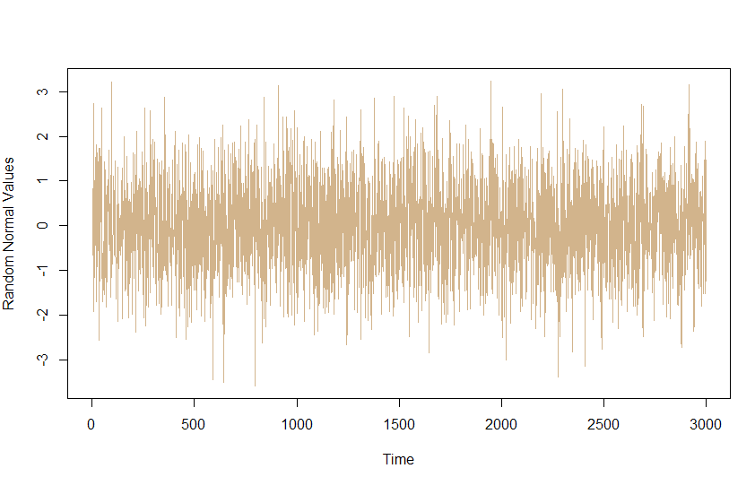A white noise process would look like:

WN_1 <- arima.sim(model=list(order=c(0,0,0)), n=300)

plot(as.xts(WN_1), lwd=0.01, col="tan", grid.ticks.on = FALSE)

plot.ts(rnorm(3000), ylab="Random Normal Values", col="tan

## Examples

* if $\vec{x}$ contained 300 values $\sim N(0,1)$ it would be a white noise process.
  + Because the values have $ACF=ACVF=μ=0$
* However a vector $\vec{y}$ containing those 300 values and another 200 values from a normal distribution with $μ=0, σ=29$ would NOT be a white noise process because the variation is not constant over time.

## Random Walk Process

A random walk process, is such that:

$$Today=Yesterday+Noise$$

And is such that:

* There is no specified mean
* Strong dependence over time
* It’s changes are white noise

A Random Walk process ($Z$) requires a starting point, usually $Z_{0}=0$.

A Random Walk Process has only one parameter, the variance of the white noise.

The difference between each value on a random walk, is white noise, i.e. diff(Z)=WN.

If $a_{t}$ is a white noise process with $E\left(a_{t}\right)=0$ and a constant variance $Var(a_{t})=σ_{a}^{2}$, then $Z_{t}$ is a random walk process:

$$Z_{t}=Z_{t-1}+a_{t}$$

For $t=1,2,3,4…$

$$z_{0}=0 \\ Z_{1}=Z_{0}+a_{1} \\ =a_{1} \\ Z_{2}=Z_{1}+a_{2} \\ =a_{1}+a_{2}$$

…

$$Z_{t}=\sum_{i=1}^{t}{\left[a_{i}\right]}$$

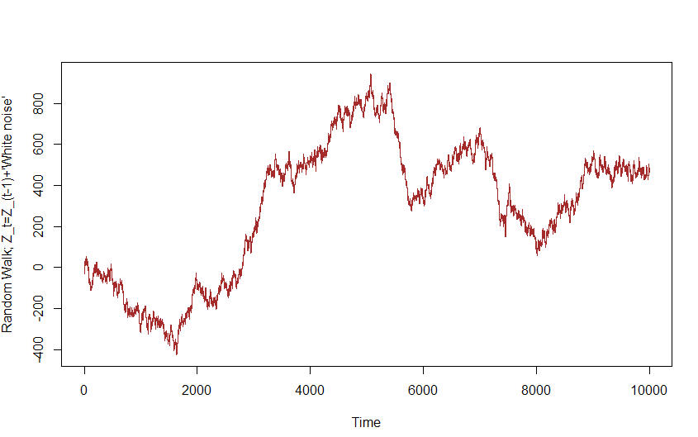A random walk process could look like this:

$$σ_{a}^{2}=8 | n=10000$$

### Mean Value

$$μ_{t}=E\left(Z_{t}\right)=E\left[\sum_{i=1}^{t}{\left[a_{i}\right]}\right]=0$$

### Variance

$$σ_{t}^{2}=Var\left(Z_{t}\right)=Var\left(a_{1}+a_{2}+a_{3}…a_{t}\right)=t×Var\left(a_{t}\right)=tσ_{a}^{2}$$

### Autocovariance

$$γ_{k}=Cov\left(Z_{t}, Z_{t+k}\right) \\ =tσ_{a}^{2}$$

I need to prove this rather than just writing it out.

### Autocorrelation

$$ρ_{k}=\frac{Cov\left(Z_{t}, Z_{t+k}\right)}{\sqrt{Var\left(Z_{t}\right)∙Var\left(Z_{t+k}\right)}} \\ =\sqrt{\frac{t}{s}}$$

## Drift

A random Walk with drift is:

$$Today=Constant+Yesterday+Noise$$

And merely adds a constant value to the form.

A white noise process with a drift has two parameters:

* White Noise Variance
* Constant $c$
  + The mean of the white noise is $c$

## Simulating in R

RW_1 <- arima.sim(model=list(order=c(0,1,0)), n=50)

as.xts(RW_1

# Moving Average Process

A moving average process of order 1 ( ***MA (1)*** ) is:

$$Z_{t}=β_{0}a_{t}+β_{1}a_{t-1}$$

Where $β_{0}$ and $β_{1}$ are constants, mean is 0 and variance is constant ($σ_{a}^{2})$.

## Variance of $Z_{t}$

Not totally clear

## Autocovariance

It can be shown that a *Moving Average Process* of order 1 has autocovariance:[3]

A *Moving Average Process* of order $q$ has autocovariance:[4]

Where:

## Autocorrelation

It can be shown that a *Moving Average Process* of order 1 has autocorrelation:[5]

A *Moving Average Process* of order $q$ has auto correlation:[6]

Where

## Example Problem from Lecture Notes

In the lecture notes the following time series is proposed:

$$X_{t}=a+bt+Z_{t}$$

Where:

* $a,b∈R ;$ constant values
* $t$ is a variable representing the time
  + We will assume that $t=1, 2, 3, 4, 5, 6…n$
* $Z_{t}$ is a stationery series, with a mean value of 0.

### Solving the Mean value function

The mean value in this case is the expected value:

$$μ_{t}=E\left(X_{t}\right) \\ =E(a+bt+Z_{t}) \\ =E\left(a\right)+E\left(bt\right)+E\left(Z_{t}\right) \\ =E\left(a\right)+b∙E\left(t\right)+E\left(Z_{t}\right)$$

|  |  |  |
| --- | --- | --- |
| $$E\left(a\right)=a$$ $a$ is just a constant value, e.g. if I had a constant value, say 5, I would expect that value to be 5 because, well, it’s 5. | $$E\left(t\right)=mean\left(t\right) \\ =mean(1,2,3,4,5,…n) \\ =\frac{1}{n}\sum_{t=1}^{n}{[t]} \\ =\frac{1}{n}\left(\frac{n\left(n+1\right)}{n}\right) \\ =\frac{(n+1)}{n}$$ | $$E\left(Z_{t}\right)=mean\left(Z_{t}\right) \\ =0$$ |

By substituting this into the equation:

$$μ_{t}=E\left(a\right)+b∙E\left(t\right)+E\left(Z_{t}\right) \\ =a+\frac{b(n+1)}{n}$$

# Stationary Time Series

A process is strictly stationary if all probabilistic behaviour is unchanged by shifts in time.[7]

This is a very strong assumption, it will often suffice to assume that a process is weakly stationary.

A process is weakly stationary if its mean, variance and covariance are unchanged by shifts in time.

A time series is stationary if the properties of the underlying model do not change through time,[8] i.e. the properties do not depend on the time at which the series is observed. [9]

A time series is said to be stationary if:[10]

* The mean function is a constant value, it does not change through time and
  + $μ_{t}∈R$; i.e. constant
* The auto covariance function does not change through time.

$γ_{t},_{s}=γ_{0,|t-s|}$

Observe that:

* Purely random processes are stationary
* MA(1) is Stationary
* Random Walk Processes are not stationary
  + Because $Cov\left(X_{k}, X_{k+t}\right)=tσ_{a}^{2}$ is dependent on time.

A time series that is stationary in this sense is known as a weak stationary, covariance stationary, second-order stationary or wide sense stochastic process. [11]

A stationary process can be modelled with fewer parameters, that’s why it is useful.

## Example

For a stationary process $(Y_{t})$ at time $(t)$, the following should be true:

$$Cov\left(Y_{2}, Y_{5}\right)=Cov(Y_{5}, Y_{8})$$

# Appendix

## Plot of Various Time Series Functions

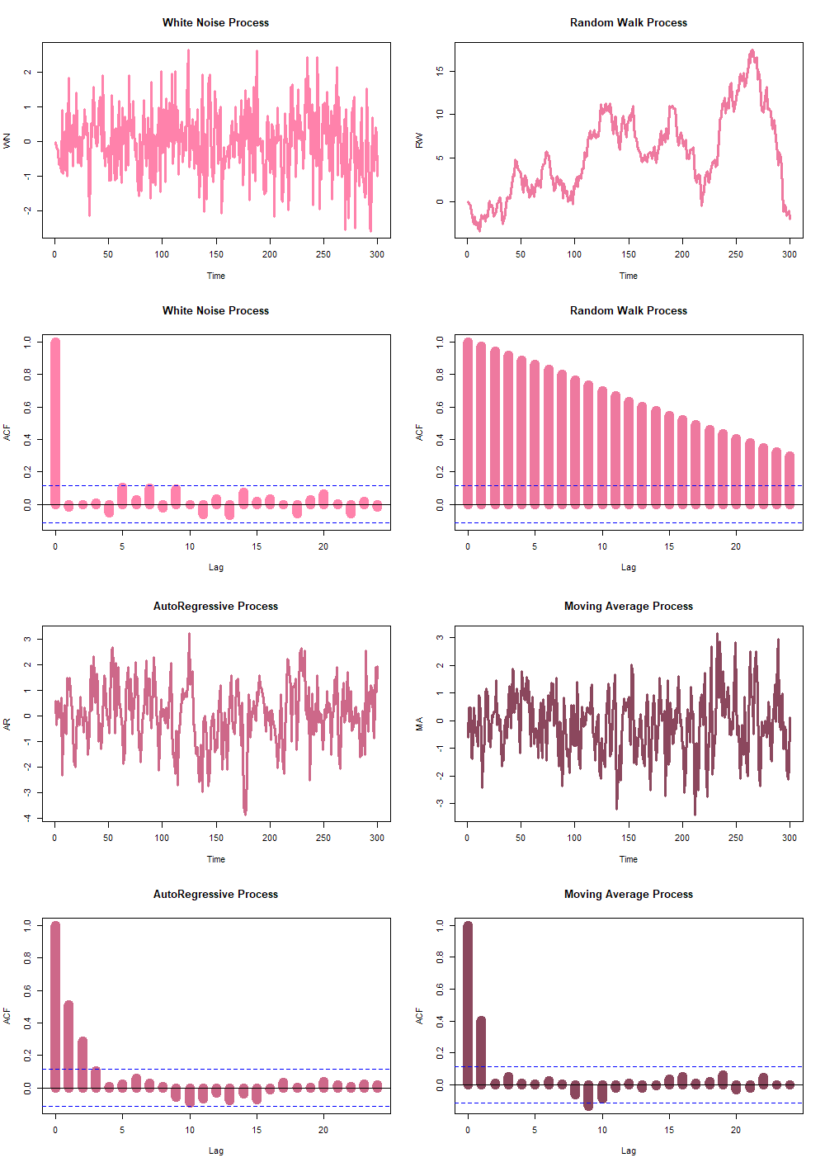

## Comparison of White Noise and Random Walk Data

# Use arima.sim() to generate WN data

white_noise <- arima.sim(model=list(order=c(0,0,0)), n=100)

# Use cumsum() to convert your WN data to RW

random_walk <- cumsum(white_noise)

# Use arima.sim() to generate WN drift data

wn_drift <- arima.sim(model=list(order=c(0,0,0)), n=100, mean=4)

# Use cumsum() to convert your WN drift data to RW

rw_drift <- cumsum(wn_drift)

# Plot all four data objects

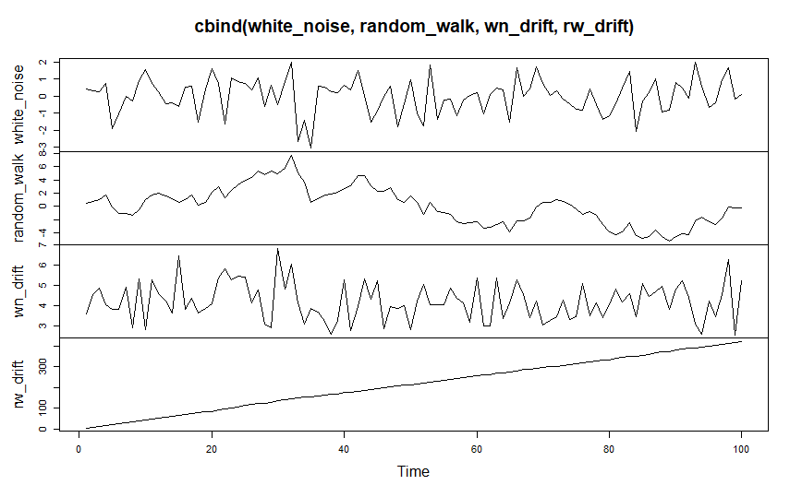plot.ts(cbind(white_noise, random_walk, wn_drift, rw_drift))

1. Oxford Dictionary of Statistics, Oxford University Press, 2002, p. 104.
2. Chatfield, C. (2000). *Time-series forecasting*. Boca Raton: Chapman & Hall/CRC.

   Equation (2.6.1), (p. 40 of 265)
3. Chatfield, C. (2000). *Time-series forecasting*. Boca Raton: Chapman & Hall/CRC.

   Equation (2.5.6), (p. 39 of 265); Compare this with the lecture notes and the formula to conclude that the numerator of the autocorrelation corresponds to the autocovariance.
4. Chatfield, C. (2000). *Time-series forecasting*. Boca Raton: Chapman & Hall/CRC.

   Equation (3.1.2), (p. 46 of 265)
5. Chatfield, C. (2000). *Time-series forecasting*. Boca Raton: Chapman & Hall/CRC.

   Equation (2.5.6), (p. 39 of 265)
6. Chatfield, C. (2000). *Time-series forecasting*. Boca Raton: Chapman & Hall/CRC.

   Equation (3.1.2), (p. 46 of 265)
7. https://s3.amazonaws.com/assets.datacamp.com/production/course_1143/slides/ch2_4_supplementary.pdf
8. Chatfield, C. (2000). *Time-series forecasting*. Boca Raton: Chapman & Hall/CRC.

   Equation (2.4.1), (p. 34 of 265)
9. Hyndman Rob J. and Athana­sopou­los George (2013) F*orecasting: Principles and Practice*, OTexts,

   <https://www.otexts.org/fpp>
10. Chatfield, C. (2000). *Time-series forecasting*. Boca Raton: Chapman & Hall/CRC.

    Equation (2.4.1), (p. 34 of 265)
11. Imdadullah, M. (2016). *Stationary Stochastic Process*. [online] Basic Statistics and Data Analysis. Available at: http://itfeature.com/time-series-analysis-and-forecasting/stationary-stochastic-process [Accessed 18 Aug. 2017].